We destroy every proud obstacle that keeps people from knowing God. We capture their rebellious thoughts and teach them to obey Christ” (2 Corinthians 10:4-5, NLT)
“We use God’s mighty weapons, not worldly weapons, to knock down the strongholds of human reasoning and to destroy false arguments”
(2 Corinthians 10:4, NLT)


March Study Guide
Weapon of the World: Self-Sufficiency

What Is Self-Sufficiency?

Definition: The belief that I must meet all my own needs—emotionally, spiritually, or materially—without relying on others or God.
Core Lie: “If I depend on no one, I can’t be disappointed.” What begins as survival often becomes a stronghold.

The Root of Self-Sufficiency

Self-sufficiency is:
- Independence masquerading as strength
- Rooted in fear (rejection, disappointment, abandonment, loss of control)
- Often formed where dependence once led to pain
It says:
- “I’ll do it myself.”
- “I don’t need what you have.” (envy disguised as strength)
- “I’m fine without help.” (pride disguised as competence)

But at its core, it is self-protection.

Signs Self-Sufficiency Is Operating in Your Life:
- Unwillingness to ask for help
- Refusing accountability or guidance
- Over functioning / overcommitting
- Using productivity to justify worth
- Dismissing weakness (ours or others’)
- Emotional distance or control
- Keeping records of wrongs
Effect: Isolation, exhaustion, resentment, and limited intimacy with God and others.
The Breakthrough Lens: 1 Corinthians 13:4–8
Love reveals the cost of self-sufficiency.
Love Is Patient & Kind
- Self-sufficiency rushes and hardens. Love rests and softens.
Love Does Not Envy, Boast, or Become Proud
- Self-sufficiency compares and performs. Love rests in identity.

Love Does Not Dishonor Others
- Self-sufficiency often dishonors through dismissal and emotional distancing. Love prioritizes connection over control.
Love Is Not Self-Seeking
- Self-sufficiency insists on its own way. Love trusts God as its source.
Love Is Not Easily Angered & Keeps No Record of Wrongs
- Self-sufficiency keeps receipts to stay guarded. Love trusts God as defender.
Love Always Trusts, Hopes, Perseveres
- Self-sufficiency perseveres alone. Love perseveres together.

The Truth That Breaks the Stronghold
John 15:5: “Apart from Me you can do nothing.”
2 Corinthians 12:9: “My grace is sufficient for you, for My power is made perfect in weakness.”
Dependence is not weakness; it is worship. Our sufficiency is found in Christ alone.
Choosing:  - Abide instead of striving  - Trust instead of control  - Receive instead of performing | Practically:  - Prayer before performance  - Rest before results  - Inviting others into the process  - Listening to wise counsel
The Spiritual Weapon: Spirit-Sufficiency
“ Finally, be strong in the Lord and in his mighty power” (Ephesians 6:10, NIV).
Fruit of Breakthrough: When self-sufficiency loosens its grip:
- Rest replaces striving
- Peace replaces control
- Grace replaces exhaustion
- Trust replaces fear
Identity shifts from: “I must handle it” to “He holds it.
Activ8ion Plan:

Review the Wound Marble Chart. Pick the top two Kerplunk layers that resonate with you.

Spend this month reviewing 1 Corinthians 13: 4-8. Which one is the most difficult for you? The least difficult? Write the verse and insert your name before each adjective. Read the verses outloud and allow yourself to believe that YOU ARE all of these and so much more! Ex.

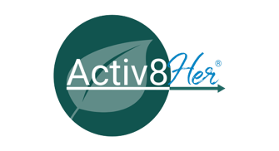

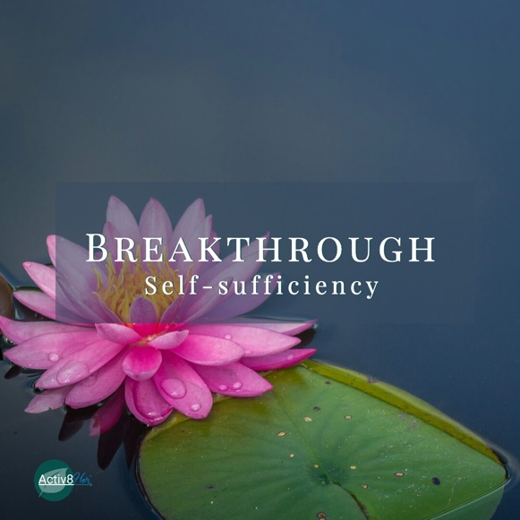
“We use God’s mighty weapons, not worldly weapons, to knock down the strongholds of human reasoning and to destroy false arguments. We destroy every proud obstacle that keeps people from knowing God. We capture their rebellious thoughts and teach them to obey Christ.”
(2 Corinthians 10:4-5, NLT).
Notes of Hope! This study guide has been designed to help you cultivate courageous faith as you explore biblical principles and engage in the Activ8ion Plan. We hope you will take these practical challenges that encourage transformation and dig deeper into this month’s theme. *Coordinator, please inform participants of your intent for the second chapter meeting.

#Breakthrough: Self-Sufficiency Four-Week Study Guide
WEEK ONE: Naming the Stronghold of Self-Sufficiency
Scripture: 2 Corinthians 10:4–5; Psalm 139:23–24
Focus: Becoming aware of self-sufficiency as a worldly weapon and identifying our "marbles."
Recognize
- Take the time to identify where self-sufficiency has become your default response.
- Acknowledge behaviors that look like strength but are rooted in fear.
- Is your determination to press ahead with plans your way of maintaining control?
  - Will you ask God to help you release this marble?

Release
- Invite God to reveal the false beliefs supporting self-sufficiency.
- Name them aloud or write them down.
  - Prayer: "Lord, show me where I’ve relied on myself instead of You."

Replace
- Begin replacing self-sufficiency with truth: God is my source.
- Read Proverbs 3:5–6

Rebuild
- Create space for God by practicing prayer before problem-solving this week.

Rejoice
- Thank God for what He is revealing. Awareness itself is a gift of grace.

.

WEEK TWO: Letting Go of Self-Made Defenses

Scripture: Isaiah 30:15
Focus: Removing the “sticks” that have been holding everything together.

Recognize
- Notice which coping mechanisms you use to avoid vulnerability or disappointment.
  - Ask God to reveal what taught you to put them in place.

Release
- Surrender control, over-functioning, and refusal to ask for help.
  - Prayer: "I release the need to protect myself and choose to trust You."

Replace
- Replace control with surrender and independence with dependence on the Holy Spirit.
- Read and practice John 15:5.

Rebuild
- Practice asking for help in one tangible way this week.

Rejoice
- Celebrate obedience over outcome. God honors surrendered hearts.

WEEK THREE: Trading Self-Sufficiency for Spirit-Sufficiency
Scripture: Galatians 2:20

Focus: Allowing Christ to become our true source.

Recognize
- Identify moments where you instinctively strive instead of abide.
  - Journal about the situation. What was pushing you?

Release
- Letting go of performance-based worth and productivity as identity requires understanding where it began. Ask God to show you where it began.
  - Prayer: "Jesus, I choose to abide instead of strive."

Replace
- Replace self-sourcing with Spirit-dependence.
  - Read 2 Corinthians 12:9

Rebuild
- Develop rhythms of rest, prayer, and connection. Does the thought of this scare you? Why?

Rejoice
- Praise God for His grace that meets you in weakness.

WEEK FOUR: Living from Love, Not Fear
Scripture: 1 Corinthians 13:4–8
Focus: Rebuilding life and relationships on love, trust, and union with Christ.

Recognize
- Notice how love flows more freely when control is released.

Release
- What would it take for you to release old patterns of withdrawal, emotional walls, and isolation.
  - Prayer: "I choose love over self-protection." (You are safe in Christ)

Replace
- Replace fear-based independence with covenant connection.
  - Read: Ephesians 6:10

Rebuild
- Who can you practice presence, vulnerability, and shared faith journeys with?

Rejoice
- Celebrate the fruit of breakthrough: rest, peace, and restored intimacy with God and others.

Closing Reflection

Self-sufficiency promises safety. It whispers, “If I don’t need anyone, I can’t be hurt.”But what it rarely tells us is the cost. It costs connection. It costs softness. It costs intimacy with God and others.

What began as survival slowly becomes a stronghold. We tighten our grip, insist on our way, and call it strength when underneath it is often fear. Fear of being disappointed again. Fear of being unseen. Fear of needing something that might not be given. But love — the kind described in 1 Corinthians 13 — cannot flourish in a clenched fist. Love is not self-seeking. Love trusts. Love hopes. Love remains.

And the beautiful truth is this: God never asked us to be our own source.

Kerplunk layer | Expression of Self-Sufficiency | Example: Stick or Defense
Surface behavior:  Refusing help  Over-functioning  Over-committing  Doing everything yourself  Struggling silently  Downplaying needs  Difficulty delegating  Taking responsibility for everyone and everything  Avoiding asking for prayer or support | “It’s easier if I just do it.”  “I don’t want to burden anyone.”  “I can handle it.”  “No one does it like I do.” | Control  Independence  Emotional containment
Hidden fear:  Fear of being let down  Fear of abandonment  Fear of appearing weak  Fear of being a burden  Fear of losing control  Fear of chaos  Fear that no one will show up | “If I don’t do it, it won’t get done.”  “I can’t trust anyone else with this.”  “I’ve learned not to depend on people.”  “Needing others never works out.” | Self-reliance  Emotional distance  Performance-based worth
Core Wound:  “I’m on my own.”  “People don’t stay.”  “Depending on others leads to hurt.”  “My needs overwhelm people.”  “It’s safer not to need anyone.” | How the wound is expressed  (often unconsciously):  Chronic independence  Emotional guardedness  Difficulty receiving love  Avoiding vulnerability  Pride masked as strength  Quiet loneliness | Where this wound usually came from:  Repeated disappointment  Inconsistent caregivers  Early over-responsibility (parentified child)  Emotional neglect  Betrayal  Having to grow up too fast

