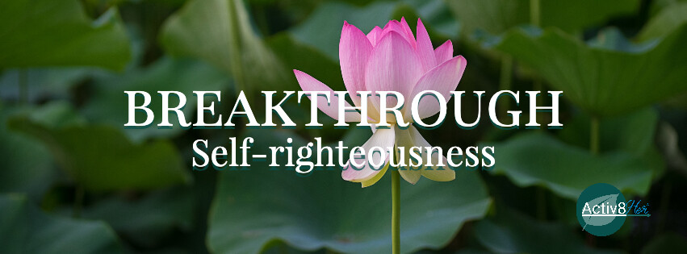

June 2026 Study Guide
Weapon of the World: Self-Righteousness & Self-Performance
“We use God’s mighty weapons, not worldly weapons, to knock down the strongholds of human reasoning and to destroy false arguments. We destroy every proud obstacle that keeps people from knowing God. We capture their rebellious thoughts and teach them to obey Christ” (2 Corinthians 10:4-5, NLT).

Core motive driving this mindset is: “I can earn or maintain God’s favor through my good behavior.” “If I try hard enough, I can earn approval through my performance as a Christian.

Self-righteousness can show up when we judge others, compare our faith, or try to control outcomes through our performance. It whispers that our service, our obedience, our outward appearance can earn approval or validate our identity in Christ. How do you relate to Kolleen and Chrissy’s struggle?

We understand we are to live lives reflective of the transformational power of Jesus. Read Matthew 3:8 and discuss how we can balance this instruction with a self-righteous attitude?

How does self-righteousness or self-performance show up in your life? Has your focus become comparison and moral superiority? Are you trapped in a cycle of performance to prove worth? Do you seek value from your effort?

Read the story of the Prodigal Son in Luke 15. One ran from the father. The other performed for the father. But neither one truly understood the heart of the father. Which are you?

Rebellion and self-righteousness often spring from the same root wound: the struggle to anchor our identity in God’s grace rather than our performance or our independence. Are you most often struggling from self-righteousness due to rebellion or self-righteousness due to performance?

When devotion becomes an obligation it’s easy to forget that God intends for our obedience to flow from love, not duty. It is when our relationship with God is conditional that self-righteousness will teach us that “God’s favor depends on my performance.”

The Weapon of the Word:
- Expose the lie. Self-righteousness is built on this belief: “My behavior earns or maintains my right standing with God.” TRUTH: “God saved you by his grace when you believed. And you can’t take credit for this; it is a gift from God. Salvation is not a reward for the good things we have done, so none of us can boast about it” (Ephesians 2:8-9, NLT).

- Replace Performance with Truth. Self-righteousness says: “I prove I’m right by what I do.” TRUTH: We are made right with God by placing our faith in Jesus Christ. And this is true for everyone who believes, no matter who we are” (Romans 3:22, NLT).

- Capture the Thought. Self-righteousness lives in subtle thoughts:
      - “I need to do more.”
      - “I should be better than this.”
      - “At least I’m doing more than they are.”
      - “If I get this right, I’ll feel secure.”
TRUTH: “We use God’s mighty weapons, not worldly weapons, to knock down the strongholds of human reasoning and to destroy false arguments. ⁵ We destroy every proud obstacle that keeps people from knowing God. We capture their rebellious thoughts and teach them to obey Christ” (2 Corinthians 10:4-5, NLT).
- Re-anchor Identity in Christ. Self-righteousness is ultimately an identity issue. It asks: “Am I enough?” Then answers: “Only if I perform well.” TRUTH: “And Abram believed the Lord, and the Lord counted him as righteous because of his faith” (Genesis 15:6, NLT).
- Shift from Proving to Receiving. We move from self-righteousness which strives, compares, performs and judges into Truth which leads us to rest, receive, trust and reflect.
Activ8ion Plan:
Self-righteousness strives to become what grace has already made you. #Breakthrough begins when you stop proving and start receiving.
Are you trying to earn what Jesus has already given you?
The antidote to self-righteousness isn’t trying harder to be humble—it’s staying in awe of grace. When we remember:“Apart from Jesus, I have nothing to boast about,” we stop competing, correcting, and comparing and simply start loving.

Notes of Hope! This study guide has been designed to help you cultivate courageous faith as you explore biblical principles and engage in the Activ8ion Plan. We hope you will take these practical challenges that encourage transformation and dig deeper into this month’s theme. *Coordinator, please inform participants of your intent for the second chapter meeting.

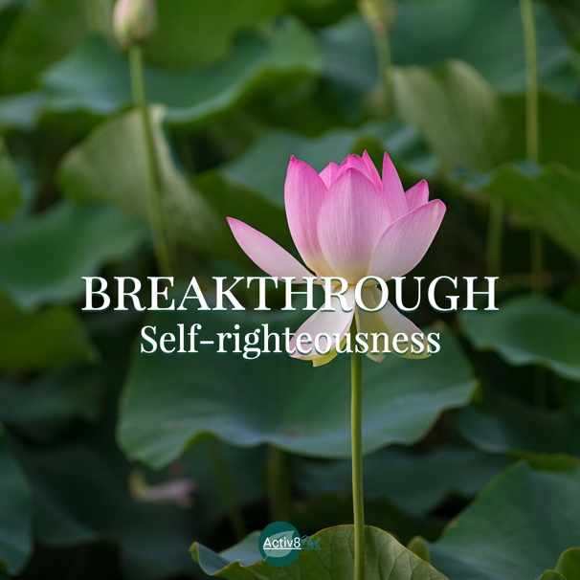

“We use God’s mighty weapons, not worldly weapons, to knock down the strongholds of human reasoning and to destroy false arguments. We destroy every proud obstacle that keeps people from knowing God. We capture their rebellious thoughts and teach them to obey Christ.”
(2 Corinthians 10:4-5, NLT).

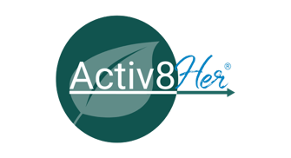
Notes of Hope: #Breakthrough Self-Righteousness/Performance
Four-Week Study Guide
Theme: Stop spinning your wheels, trust God, and experience breakthrough through His Word.
Week 1 Recognizing the Performance Trap

Scripture“It is by grace you have been saved, through faith… not by works.” — Ephesians 2:8–9

Focus Identifying how self-righteousness turns relationship into performance.

Recognize Where am I trying to earn what God has already given?
- Performing instead of resting
- Saying yes out of obligation
- Measuring my faith by what I do rather than who I am

Release: Release the pressure to prove your devotion. Let go of the belief: “If I do more, I will be more accepted.”

Replace Replace performance with grace: “I am accepted because of Christ, not because of my behavior.”

Rebuild Begin practicing being with God instead of performing for Him. Spend time in His presence without an agenda.

Rejoice Rejoice that your relationship with God is not fragile—it is secure in grace

Week 2: Revealing the Wound Beneath the Behavior

Scripture “The Lord looks at the heart.” — 1 Samuel 16:7

Focus Understanding the wound marbles beneath self-righteous behavior.

Recognize What “marbles” am I carrying?
- Fear of rejection
- Shame or inadequacy
- Fear of disappointing God
- Need for approval
What behaviors are protecting them?
- People-pleasing
- Over-serving
- Avoiding weakness
- Comparing or judging

Release Release the need to protect your wounds through performance. Invite God into the places you’ve been hiding.

Replace: Replace fear with truth: “God sees me fully and still loves me completely.”

Rebuild Allow God to redefine your identity at the root—not just your behavior. Journal: What has shaped my need to perform?

Rejoice Rejoice that God is not intimidated by your wounds—He heals them.

Week 3: Shifting from Performance to Grace

Scripture “Abram believed the Lord, and He credited it to him as righteousness.” — Genesis 15:6

Focus Receiving righteousness as a gift, not something to achieve.

Recognize Where am I still trying to:
- Prove my righteousness?
- Control outcomes through behavior?
- Compare my faith to others?

Release Release comparison, control, and the need to “get it right.” Let go of: “My behavior proves my righteousness.”

Replace: Replace striving with truth: “Righteousness is received by faith, not achieved by effort.”

Rebuild: Start living from identity, not for identity:
- Obey from love, not obligation
- Serve from overflow, not pressure
Rejoice: Rejoice that you don’t have to earn what Jesus already finished.

Week 4: Living in Breakthrough Identity
Scripture: “Righteousness is given through faith in Jesus Christ to all who believe.” — Romans 3:22–23
Focus: Walking in freedom from self-righteousness into grace-filled identity.
Recognize: Where has self-righteousness affected how I see others?
- Judgment
- Criticism
- Spiritual comparison
- Lack of compassion or empathy
Release: Release the need to measure yourself—or others—by performance. Let go of: “I must uphold the standard to be accepted.”

Replace: Replace judgment with grace: “I extend the same grace I’ve received.”

Rebuild: Build a life marked by:
- Humility
- Compassion
- Gratitude
- Dependence on God

Let your life reflect Christ, not prove Him.

Rejoice: Rejoice in this truth: I don’t have to prove my righteousness, I get to live from it.

Final Breakthrough Declaration: Performance can never earn what grace freely gives. #Breakthrough begins when I stop striving to be right and start resting in the righteousness already given to me through Christ.

