

May 2026 Study Guide
Weapon of the World: Self-Striving

“We use God’s mighty weapons, not worldly weapons, to knock down the strongholds of human reasoning and to destroy false arguments. We destroy every proud obstacle that keeps people from knowing God. We capture their rebellious thoughts and teach them to obey Christ” (2 Corinthians 10:4-5, NLT).

Strive: “to devote serious effort or energy or to struggle in opposition” (Merriam-Webster).

Self-sufficiency is the mindset: “I can’t rely on anyone. It’s up to me.”
Self-striving is the motion: Overthinking. Overworking. Overcontrolling.
The emotional spinning that we put ourselves through to make things happen.

Have you ever been stuck—spinning your wheels, putting in effort but seeing no real breakthrough?

Where in your life do you currently feel stuck, even though you’re trying your best to move forward? This becomes the frustration of: activity without progress, emotion without resolution and effort without breakthrough.

Striving isn’t just about working hard—it’s about internal struggle. It’s the emotional tension that comes from trying to fix, prove, defend, or control something in our own strength.

Inner striving can up quietly in our thoughts and feelings. For example:
- Replaying the same hurt: When we are thinking through an interaction that left us hurt, the internal dialogue might sound like:
    - “What should I have said differently?”
    - “Why didn’t they act like they even care?”
    - “What did I do to deserve that?”
You’re emotionally moving but you are not healing. That’s spinning your wheels.

- It might show up as: overprocessing instead of surrendering.
    - We can try to think our way into peace by: analyzing motives, rewriting scenarios or mentally coming up with reasons for your actions.
Your mind is active but your heart is still stuck. That is spinning your wheels.

3. Staying in reaction mode: When self-striving keeps you:
- Relying on your own strength instead of God’s.
- Feeling the need to control every outcome.
- Distrusting others to care or act rightly.
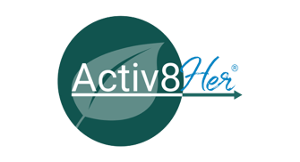
  - You stay: Triggered easily, Defensive quickly, Guarded constantly.
Your energy goes into protecting yourself rather than leaning into God’s freedom. That’s spinning your wheels.

4. Waiting for closure from people. Spinning wheels looks like:
      - Waiting for an apology
      - Waiting to be understood
      - Waiting for acknowledgment
      - Waiting for acceptance.
      - “Why couldn’t they give me what I needed to be able to move on?”
You’re paused emotionally because you’re waiting for someone else to move and to make you feel complete or defined. That’s spinning your wheels.

5. Trying to fix what you can’t control. You spin when you try to:
- Change how someone sees you or earn the sense of belonging or work to repair a one-sided relationship.
You push harder but the terrain or the outcome isn’t improving.
Adjusting requires:
- Letting go
- Accepting reality
- Releasing expectations
- Grieving what won’t change
Spinning feels productive. Adjusting feels like surrender. But only one leads to freedom

The worldy weapon of self-striving uses willpower instead of surrender, control instead of trust and fixing instead of yielding. Human reasoning + self-effort is rooted in:
- Fear of failure
- Fear of rejection
- Distrust of God’s timing
- Identity confusion

The obstacle is spinning our wheels is misapplied effort fueled by misaligned thinking.
Which of these core rebellious thoughts are behind your self-striving?
“It’s all up to me.” | Root: | Lie: | Truth:
“If I stop striving, everything will fall apart.”

I have to fix this to move forward.”
“If I don’t try harder, I’ll just stay stuck.”

“I can’t trust God with this part. But I’m going to hang on to this area over here.”

“I just need more time to figure it out.”

Activ8ion Plan:
Review the Wound Marble Chart.
Consider the following for group discussion:
- What outcome am I striving for that I don’t yet trust God to accomplish without my control?
- What thought am I believing that makes me feel like everything depends on me?
- When I feel stuck, do I pause to capture and question my thoughts—or do I push harder in the same direction? Am I willing to interrogate my thoughts?
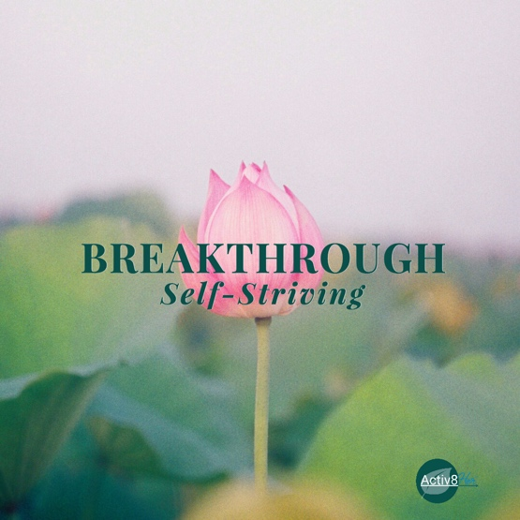
Notes of Hope! This study guide has been designed to help you cultivate courageous faith as you explore biblical principles and engage in the Activ8ion Plan. We hope you will take these practical challenges that encourage transformation and dig deeper into this month’s theme. *Coordinator, please inform participants of your intent for the second chapter meeting.

“We use God’s mighty weapons, not worldly weapons, to knock down the strongholds of human reasoning and to destroy false arguments. We destroy every proud obstacle that keeps people from knowing God. We capture their rebellious thoughts and teach them to obey Christ.”
(2 Corinthians 10:4-5, NLT).

#Breakthrough: Self-Striving Four-Week Study Guide
Theme: Stop spinning your wheels, trust God, and experience breakthrough through His Word.
Week 1: Recognizing Self-Striving
Scripture: "We use God’s mighty weapons, not worldly weapons, to knock down the strongholds of human reasoning and to destroy false arguments" (2 Corinthians 10:4-5 NLT).
Focus: Understand what self-striving is and how it shows up in your life.
Recognize: Where am I overthinking, overworking, or over-controlling?
- What areas of my life feel like spinning wheels with no progress?
- Which emotions keep resurfacing—frustration, anxiety, exhaustion?

Release: Release the need to control outcomes or “fix” every situation.
- Surrender the areas where effort hasn’t brought breakthrough.

Replace: Replace self-effort with surrender to God’s timing.
- What would it look like for you to invite God to be your solution and guide.

Rebuild: Practice pausing before reacting.
- Journal one area where you can stop striving and wait on God this week.

Rejoice: Celebrate the awareness that you don’t have to do it all.
- Praise God for His strength that works where your effort cannot.

Week 2: Stop Striving for Approval – Trust God’s Favor
Scripture: “For the Lord God is a sun and shield; the Lord bestows favor and honor. No good thing does he withhold from those who walk uprightly” (Psalm 84:11, NIV).
Focus: Stop striving for human approval. God is your protector, your source of favor, and the one who sees your worth. You don’t need to earn love, validation, or acceptance from people — God has already provided it.
Recognize: Self-striving often surfaces when we feel rejected, overlooked, or unappreciated.
- Lies your heart may believe:
  - “If they don’t notice me, I’m not enough.”
  - “I must earn love and favor to be valued.”
  - “I can’t rest until I make things right.”
- Signs you’re seeking approval: overexplaining yourself, overworking, replaying conversations, or trying to fix others’ perceptions.

Release: Release the need to earn affirmation from others.
- Let go of the invisible “approval ledger” in your heart — the tally of who has or hasn’t recognized you.
- Surrender the belief that your worth depends on human acknowledgment.

Replace: Replace striving with trust: “God is my sun and shield. He bestows favor and honor on me.”
- When you catch yourself spinning your wheels for someone’s approval, pause and recite the verse. Let it remind you: God sees you, values you, and equips you for breakthrough.
- Anchor your identity in God’s favor, not people’s opinions.

Rebuild: Create new habits of resting in God’s affirmation:
- Journaling ways God has shown His favor in your life.
- Affirming yourself with God’s truth daily.
- Sharing your victories and challenges with someone who builds you up spiritually, instead of trying to impress or gain their approval.

Rejoice: Celebrate freedom from the need to be validated by others.
- Thank God that His favor and protection are yours, unearned and unshakeable.
- Rejoice that your worth is anchored in Him, and self-striving no longer has the power to define you.

Week 3: Capturing Rebellious Thoughts
Scripture: “Do not conform to the pattern of this world, but be transformed by the renewing of your mind" (Romans 12:2 NLT).
Focus: Learn to capture thoughts that fuel self-striving.
Recognize: Identify thoughts that say: “It’s all up to me,” “If I don’t try harder, it won’t work,” or “I have to fix this to move forward.”
- Become intentional to notice when striving feels productive but leaves your heart exhausted.
Release: Release the lie that you are responsible for outcomes beyond your control.
- Stop believing striving equals spiritual success.
Replace: Replace rebellious thoughts with truths from God’s Word.
- Example: “Apart from Him, I can do nothing; in Christ, I have strength and guidance.”
Rebuild: Create a “thought-capturing” ritual: when you notice a striving thought, stop, write it down, and replace it with God’s truth.
- Practice this at least once a day.
Rejoice: Celebrate the power of God’s Word to realign your mind and heart. Praise Him for the freedom to trust instead of striving.

Week 4: Surrender and Breakthrough
Scripture: Psalm 37:5 (NLT) "Commit everything you do to the Lord. Trust Him, and He will help you."
Focus: Move from self-striving to surrender and experience breakthrough.
Recognize: What areas of my life am I still trying to control?
- Where am I resisting letting go because it feels risky?
Release: Release control over outcomes, relationships, or unresolved hurts.
- Let go of striving to “earn” love, approval, or success.
Replace: Replace striving with abiding: resting in God, meditating on His promises, trusting His timing.
- Feed on scriptures about God’s faithfulness and provision.
Rebuild: Identify one area to fully surrender this week.
- Pray and commit it to God, acknowledging His sovereignty and love.
Rejoice: Celebrate the breakthrough that comes from letting go and trusting God.
- Rejoice that your freedom is not based on effort, but on surrender and His Word.

Kerplunk layer | Expression of Self-Striving | Example: Stick or Defense
Top Layer  Surface behavior | - Over-explaining yourself  - Replaying conversations  - Trying to “fix” misunderstandings  - Working harder for connection  - Emotional over-processing  - Reaching out again… and again | Over-effort-ing / over-owning  “If I try harder, maybe this won’t fall apart.”
Middle Layer  Hidden fear | This is where wheel-spinning lives  Fear: Loss of connection or unresolved tension  You're not trying harder because you're strong.  You're trying harder because you're afraid of what dropping the sticks means | - “If I stop trying, the relationship dies.”  - “If I don’t fix this, it stays broken.”  - “Silence means rejection.”  - “Letting go means I didn’t matter.”  - “Letting go means my pain wasn’t justified.
Bottom Layer  Core Wound | - Rejection  - Not being chosen  - Not being seen as worthy of repair  - Abandonment of the heart | The deepest belief often sounds like:  “If I stop striving, I’ll discover I was never worth staying for.”  Or even more quietly:  “Love doesn’t hold onto me unless I hold it together.”  That’s the marble. And it’s heavy.

