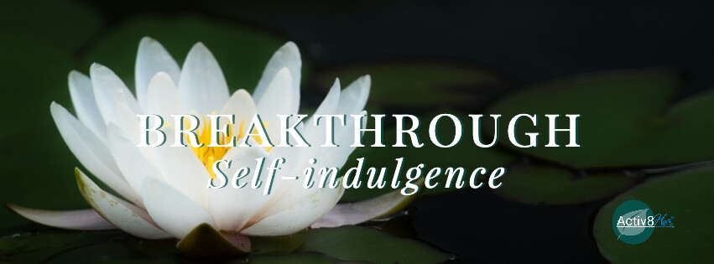
September 2026 Study Guide
Weapon of the World: Self-Indulgence

“We use God’s mighty weapons, not worldly weapons, to knock down the strongholds of human reasoning and to destroy false arguments. We destroy every proud obstacle that keeps people from knowing God. We capture their rebellious thoughts and teach them to obey Christ” (2 Corinthians 10:4-5, NLT).

Self-Indulgence: “excessive or unrestrained gratification of one's own appetites, desires, or whims.” (Merriam-Webster) It is the habit of soothing, rewarding, or protecting self without restraint, using pleasure, distraction, or excess to fill emotional or spiritual emptiness.

Unlike self-preservation (“protect me”), self-reliance ("I can do it myself"), or self-righteousness ("look at what I've done"), self-indulgence says: “I deserve relief from this pain, and I want it now.”
Self-indulgence can disguise itself as self-care, reward, comfort, or relief. What begins as a way to cope can slowly become a way of life. Self-indulgence as a weapon of the world:
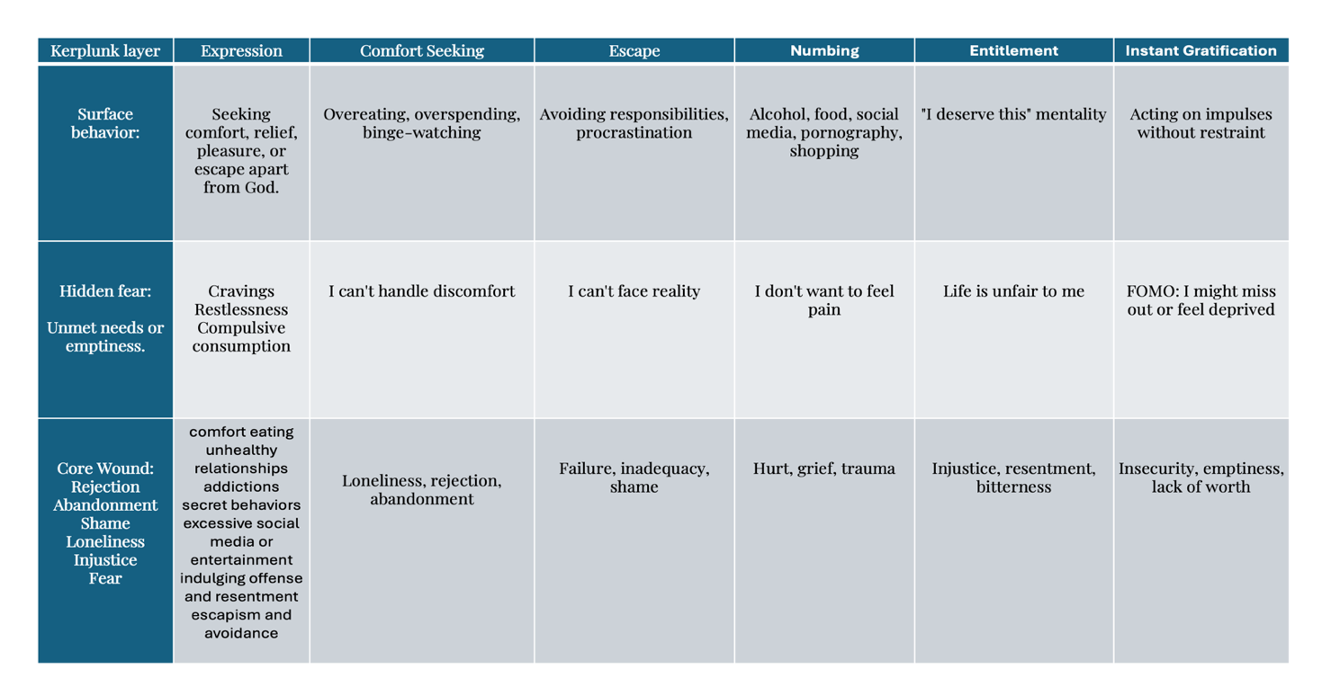
The question isn’t am I capable. The question is whether I am willing to endure the discomfort required to become capable. On a scale of 1 to 10 (one being least willing) How willing am I? _________ What is the reason for your answer?

Growth often requires discomfort. Healing requires discomfort. Forgiveness requires discomfort. Discipline requires discomfort. Obedience requires discomfort. Jesus is our example. “…For the joy set before Jesus he endured the cross, scorning its shame, and sat down at the right hand of the throne of God” (Hebrews 12:2, NIV) Self-indulgence promises relief from discomfort, but self-control produces freedom through it.

Self-indulgence begins with excuses. What is one common excuse you’ve heard or used?

Weapon of the Word: We battle self-indulgence with the Spiritual Weapon of Self-Control: Choose Spirit-led discipline over flesh-led indulgence.

“‘Heaven is my throne, and the earth is my footstool hat kind of house will you build for me?’ says the Lord. Or where will my resting place be?’” (Acts 7:49, NIV).

"Do you not know that your bodies are temples of the Holy Spirit, who is in you, whom you have received from God? You are not your own; you were bought at a price. Therefore honor God with your bodies" (1 Corinthians 6:19-20, NIV).

Self-indulgence is often the symptom. The wound is the source. So where do we go from here? God wants us to breakthrough Self-Indulgence so we can press into Him and live satisfied because He is our Source, not the wound.

"Blessed are those who hunger and thirst for righteousness, for they shall be satisfied" (Matthew 5:6).

“For God gave us a Spirit who produces not timidity, but power, love and self-discipline.” (2 Timothy 1:7, CJB)

“But the fruit of the Spirit is love, joy, peace, forbearance, kindness, goodness, faithfulness, ²³ gentleness and self-control. Against such things there is no law” (Galatians 5:22-23, NIV).

“We must all suffer from one of two pains: the pain of discipline or the pain of regret. The difference is discipline weighs ounces while regret weighs tons.” –Jim Rohn

Some of us hunger for comfort.
Some hunger for acceptance.
Some hunger for relief from pain.
Some hunger for significance.
Some hunger for peace.
The question is not whether we are hungry. The question is where we are going to satisfy that hunger.

Self-indulgence says, "Feed the craving."
Religion says, "Fight the craving."
Jesus says, "Bring the craving to Me and I will transform your desires."

When we find a breakthrough, we find contentment. “I have learned to be content whatever the circumstances” (Philippians 4:11, NIV).
Activ8ion Plan:

From the book, The Body Teaches the Soul by Justin Whitman Early.

Daily/Weekly Habits: Daily Scripture Before Phone. Refuse to open your phone before you’ve meditated on Scripture 5–10 minutes.

Weekly Meditative Walk: Once a week take a walk outside. Don’t bring a phone. Just spend twenty minutes with God and your mind, praying or reflecting.

One Hour with Your Phone Off Each Day: This is an amazingly helpful practice to reclaim your daily ability to pay attention to other people.

Weekly Church Community: A small group of friends with whom you can truly be known. This community can be in many forms, but the key is vulnerability. Hello Activ8Her!!

Journaling: One of the reasons journaling is so good for mental health is because it helps you realize you have a story, and you must practice paying attention to that narrative if you’re going to see how God is working in your story.

Weekly Hour of Deep Conversation: We now know that loneliness is killing people in the West, because our bodies were made to have deep relationships with other people. A single face-to-face conversation with a good friend every week is one of the healthiest things you can do for your mind and body.

Daily Walk Outside: One of the ways we can engage our right brains is to be awed by the magnificence of creation. Simply walking outside can help with this.

He encourages us to Engage with Art Weekly: Many people may not realize how spiritual it is to read regularly, but God made us with an imagination. We need to exercise our imagination if we’re going to engage in the big story of the Bible.

Resource: The Body Teaches the Soul by Justin Whitman Early.
Activ8Her Notes of Hope

#Breakthrough: Self-Indulgence

Breakthrough Self-Indulgence: From Self-Indulgent to Satisfied

Theme Scripture "For though we live in the world, we do not wage war as the world does. The weapons we fight with are not the weapons of the world..." (2 Corinthians 10:3-4)

WEEK ONE: Recognizing the Craving Beneath the Comfort

Scripture: Write James 1:14-15 here:

Focus: Self-indulgence rarely appears as rebellion. More often it disguises itself as comfort, reward, relief, or self-care. What begins as a way to cope can slowly become a way of life. God invites us to look beyond our behaviors and identify the deeper hunger driving them.

Recognize: What comfort, habit, distraction, or behavior do I turn to most often when I am stressed, lonely, frustrated, tired, or overwhelmed?
Reflection Questions:
- What craving am I feeding?
- What emotion am I trying to avoid?
- What need am I trying to satisfy?
- When do I feel most tempted to seek immediate relief?

Release: Bring your craving honestly before God. Prayer: "Lord, show me what is underneath my desire for comfort. Reveal any wounds, fears, disappointments, or unmet needs I have been trying to soothe apart from You. Help me stop hiding behind coping mechanisms and trust You with the deeper issue."

Replace: Replace the question: "How can I feel better right now?" With: "What is my soul actually hungry for?" Practice: Before reaching for your usual source of comfort, pause and spend five minutes asking God what your craving is trying to communicate.

Rebuild Begin a "Craving Journal." Each day record:
- What happened?
- What did I crave?
- What emotion was underneath it?
- What truth from God's Word speaks to that need?

Rejoice: Thank God that He is revealing what has been hidden.
Declaration: "God is exposing wounds not to shame me but to heal me. Every craving can become an invitation to greater intimacy with Him."

WEEK TWO: Becoming a Dwelling Place

Scripture: Write 1 Corinthians 6:19-20 here:

Focus: Paul reminds us that we belong to God. Our bodies, minds, and hearts are His dwelling place. Self-indulgence often invites destructive tenants into a house that belongs to Him. Breakthrough begins when we see ourselves as God's temple rather than owners of our own lives.

Recognize: What "tenants" have I allowed to take up residence in God's house?
Examples:
- Bitterness
- Fear
- Unforgiveness
- Self-pity
- Gossip
- Addictive behaviors
- Unhealthy habits
Reflection Questions:
- What have I been feeding?
- What have I allowed to remain in God's house that He does not want to share space with?
- What would change if I truly viewed myself as His dwelling place?

Release: Prayer: "Father, forgive me for partnering with things that do not belong in the home You purchased with Christ's blood. I surrender every habit, attitude, and behavior that competes with Your presence."

Replace: Replace ownership with stewardship. Instead of: "My body, my choice." Choose:
"I belong to God, and my life is His dwelling place."

Rebuild: Ask yourself daily: "What kind of home am I offering the Holy Spirit today?" Choose one practical way to honor God physically, emotionally, mentally, or spiritually each day.

Rejoice: Celebrate God's presence.
Declaration: "The Holy Spirit lives within me. I am not abandoned, empty, or alone. God has made His home in me."

WEEK THREE: Choosing Growth Over Comfort

Scripture: Write Galatians 5:22-23 here:

Focus: The opposite of self-indulgence is not punishment or deprivation. It is Spirit-empowered self-control. Self-control is not about trying harder; it is about surrendering more completely to the Holy Spirit and allowing Him to reorder our desires.

Recognize: Where am I avoiding discomfort?
Reflection Questions:
- What challenge am I tempted to quit?
- What excuse do I frequently make?
- What area of growth feels difficult right now?
- Have I confused comfort with peace?

Release: Prayer: "Holy Spirit, I surrender my need for immediate relief. Strengthen me to embrace the discomfort that leads to growth, freedom, healing, and maturity."

Replace: Replace: “I deserve relief.” With: “God is using this moment to strengthen me.” Replace: “I can't do this.” With: “God can develop in me what I do not yet possess.”

Rebuild: Choose one spiritual discipline to practice daily this week:
- Prayer
- Scripture reading
- Worship
- Fasting
- Gratitude
- Silence and solitude
- Journaling
Consistency matters more than intensity.

Rejoice: Celebrate every small victory.
Declaration: "The Holy Spirit is producing self-control within me. What once seemed impossible is becoming possible through His power."

WEEK FOUR: Satisfied in Christ

Scripture: Write Matthew 5:6 here:

Focus: God never intended us to live empty. He intended us to be filled by Him. Self-indulgence seeks satisfaction in lesser things; Christ alone satisfies the deepest hunger of the soul.

Recognize: What am I expecting to satisfy me that was never designed to carry the weight of my deepest needs?
Reflection Questions:
- What am I asking food, relationships, success, entertainment, or comfort to provide?
- What hunger keeps resurfacing?
- Have I brought that hunger honestly before Jesus?

Release: Prayer: "Jesus, I bring my hunger to You. I release my expectation that lesser things can satisfy what only You can fill. Become my source, my comfort, my peace, and my satisfaction."

Replace: Replace: "Feed the craving." With: "Bring the craving to Jesus." Meditate on Philippians 4:11:"I have learned to be content whatever the circumstances."

Rebuild: Create a "Satisfaction List."
When cravings arise:
- Worship
- Read Scripture
- Take a prayer walk
- Journal
- Practice gratitude
- Call a trusted friend
- Spend time in God's presence
Develop new pathways that direct hunger toward Christ.

Rejoice: Celebrate the fruit of breakthrough: Contentment.
Declaration: "I no longer need lesser things to fill God-sized spaces. Christ is enough. In Him I have peace, freedom, and lasting satisfaction."

Final Thought
Self-indulgence says, “Feed the craving.”
Religion says, “Fight the craving.”
Jesus says, “Bring the craving to Me.”
The breakthrough comes when we stop asking temporary comforts to satisfy eternal needs and allow Christ to become our source. As we walk with Him, the Holy Spirit transforms our desires, strengthens our self-control, and teaches us the secret of contentment.
"Blessed are those who hunger and thirst for righteousness, for they shall be satisfied." –Jesus

