Rehash: Breakthrough:Self-Denial

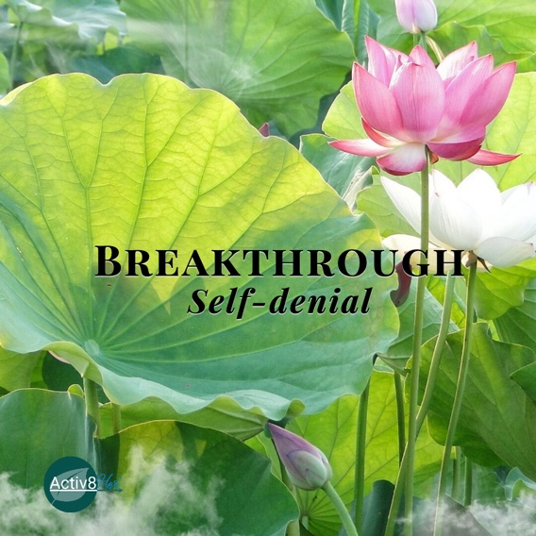
“Why do you look at the speck of sawdust in your brother’s eye and pay no attention to the plank in your own eye? How can you say to your brother, ‘Let me take the speck out of your eye,’ when all the time there is a plank in your own eye? You hypocrite, first take the plank out of your own eye, and then you will see clearly to remove the speck from your brother’s eye” (Matthew 7:3-5, NIV).

Jesus never said the speck wasn’t there. Why is that distinction important?

How can acknowledging someone else’s behavior be true while still recognizing that our response to it may need examination?

Think about a conflict where you were convinced the other person was the problem. If you looked at the situation through Jesus' “plank before speck” teaching, what might you see differently?

What part of the situation is yours to own, even if the other person genuinely has something to own too?

What does self-denial look like in real life; not just refusing to admit we're wrong?

Where do you see yourself shifting blame, justifying an attitude, excusing a reaction, or making someone else the reason you feel stuck?

1.Search Me: "Search me, God, and know my heart; test me and know my anxious thoughts. See if there is any offensive way in me, and lead me in the way everlasting." (Psalm 139:23-24, NIV). What might God be trying to show you about yourself that you cannot see on your own and are you willing to ask Him to reveal it before you defend yourself?

2. Show Me: Do not merely listen to the word, and so deceive yourselves. Do what it says. (James 1:22, NIV). When you read or hear God’s Word, do you tend to think, “Who needs to hear this?” or “Lord, what are You saying to me?” What might God be inviting you to see in yourself?

3. Change Me: "Whoever conceals their sins does not prosper, but the one who confesses and renounces them finds mercy" (Proverbs 28:13, NIV). What are you currently tempted to
conceal, excuse, or avoid that God may be inviting you to confess and surrender so He can bring healing and freedom?

This month’s declaration: I no longer have to protect myself from the truth because my identity is secure in Christ. I choose self-awareness over self-denial. I welcome God's conviction because His truth leads to freedom, not shame. "Search me, God, and lead me in the way everlasting."
